Nate Lawson
DMD, PhD
Tenured Professor · Director, Division of Biomaterials
University of Alabama at Birmingham School of Dentistry
nlawson@uab.edu · 219-789-2448 · drnatelawson.com · @dentinaltube · Birmingham, AL

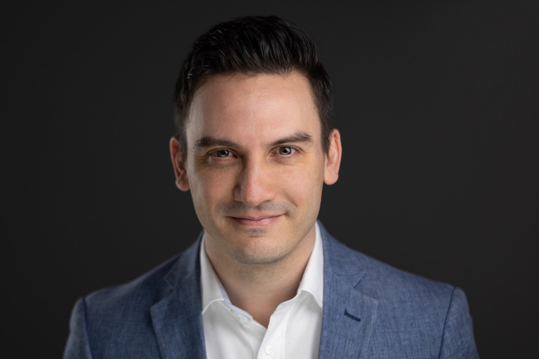

BIOGRAPHY
Nate Lawson is a tenured professor and the Director of the Division of Biomaterials at the University of Alabama at Birmingham School of Dentistry. He graduated from the UAB School of Dentistry in 2011 and completed his PhD in Biomedical Engineering in 2012. He has published more than 100 peer-reviewed articles along with 200 research abstracts and trade articles. He previously served on the ADA Council on Scientific Affairs and currently serves on the editorial boards of the Journal of Adhesive Dentistry and the Journal of Esthetic and Restorative Dentistry. He also practices as a general dentist in the UAB Faculty Practice.
SPEAKING LOGISTICS

AUDIOVISUAL REQUIREMENTS  Computer: MacBook Pro — speaker brings own laptop; HDMI adapter provided  Presentation: Keynote, 16:9  Projector / screen: No specific requirements  Microphone: Lavalier preferred; any type acceptable |  | HONORARIUM AND TRAVEL  $7,000  Economy airfare  Hotel accommodation (one night)  Sponsor contact information available on request.
DISCLOSURE OF COMMERCIAL RELATIONSHIPS
Through my position at UAB, I have received current or previous grant support from:
Solventum (3M), Kuraray, Dentsply, Ivoclar, DMG, GC, Doxa, Vista, Glidewell, Digital Dental, Pulpdent, Kerr, Microcopy, Bisco, Clinician’s Choice, Premier, Kulzer, Danville, EnvisionTEC, SprintRay, and Henry Schein.
Through my speaking, I have received previous honoraria from:
Solventum (3M), Kuraray, Dentsply, Ivoclar, DMG, GC, Doxa, Vista, Pulpdent, Kerr, Bisco, Clinician’s Choice, Danville, Dental Savings Club, and Overjet.
COURSE OFFERINGS

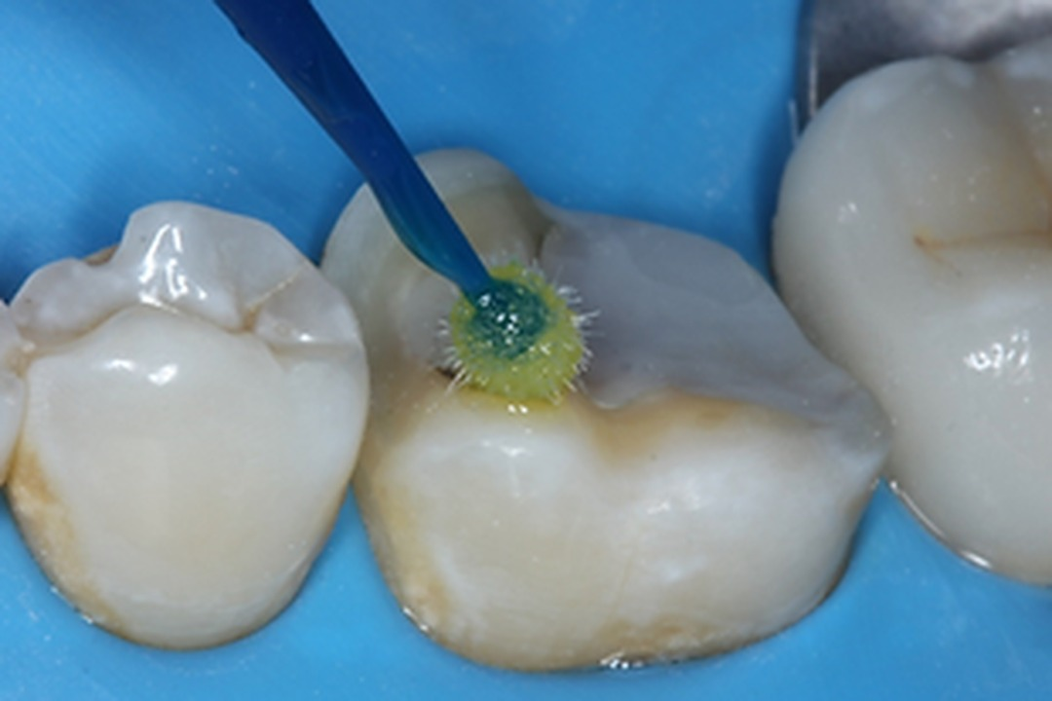
Materials and Techniques to Improve Your Conservative, Adhesive Dentistry
LENGTH 6 hours — may be delivered as two separate half-day courses | AUDIENCE Dentists, assistants
ALTERNATIVE TITLE Update to Dental Materials
Conservative dentistry aims to remove as little tooth structure as possible during restorative procedures in order to extend the lifetime of each tooth, and adhesive dentistry is what makes this possible. Bonding to tooth structure allows minimally invasive preparations to be performed predictably. This course discusses conservative treatment options together with the materials and techniques used to deliver them. For direct restorations, it reviews diagnosis, isolation, caries removal, cavity preparation, liner selection, matrix and wedge placement, bonding technique, composite placement, and finishing and polishing. For indirect restorations, it covers the selection, handling, and bonding of contemporary dental ceramics. The presentation draws on current evidence generated at the UAB School of Dentistry alongside the wider literature, with an emphasis throughout on findings that can be applied directly in the dental clinic.
Course objectives
- Learn bonding protocols for lithium disilicate onlays and zirconia resin-bonded bridges
- Learn cementation and bonding protocols for zirconia crowns with self-adhesive or RMGI cements
- Discuss design considerations for posterior and anterior bridges
- Discuss thresholds for operative treatment of incipient carious lesions and the management of deep caries
- Review the research on adhesive system selection for direct composites
- Learn new materials and techniques for Class II restorations
- Review the materials and evidence for composite adjustment and polishing techniques

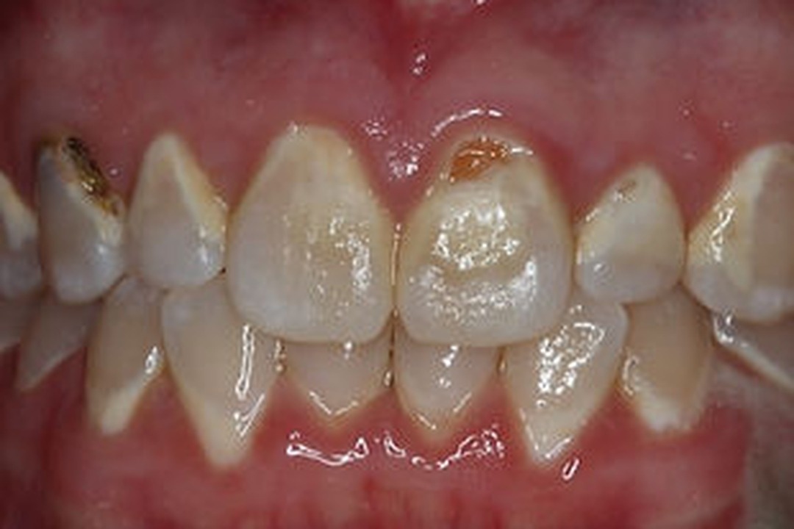
Treatment of the High Caries Risk Patient
LENGTH 3 hours — may be shortened or expanded | AUDIENCE Dentists, assistants, hygienists
ALTERNATIVE TITLE Caries-Free Menu
This lecture covers the diagnosis of caries lesions and provides guidance on appropriate thresholds for intervention. An evidence-based framework for developing an individualized prevention plan is outlined, addressing diet, hygiene, salivary flow, the oral microbiome, and pH control. The evidence for xylitol, hydroxyapatite toothpaste, antibacterials, probiotics, and other preventive agents is reviewed.
Course objectives
- Learn the current evidence for caries initiation thresholds
- Identify risk factors for high caries risk patients and learn specific treatments
- Understand the evidence supporting various caries prevention products

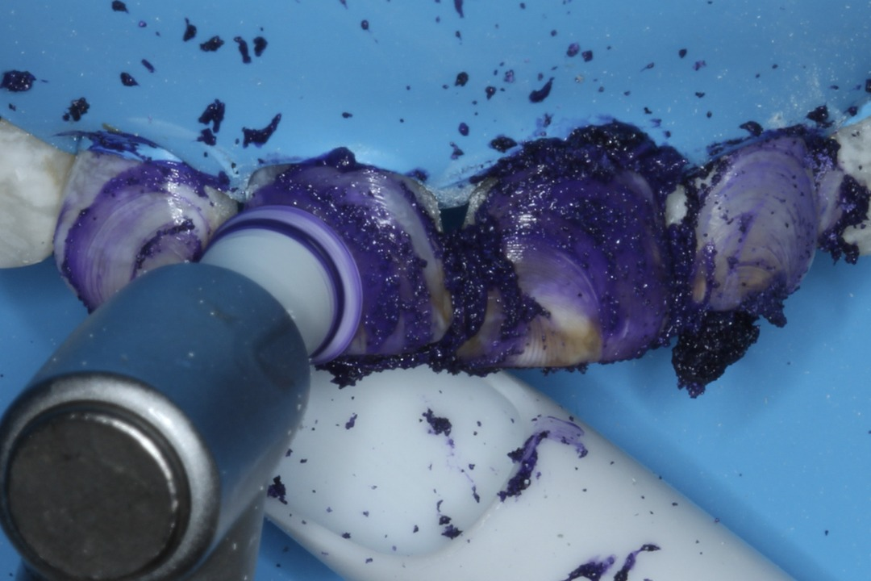
A Guide to Treating Anterior Discolorations
LENGTH 3 hours — may be shortened or expanded | AUDIENCE Dentists, assistants, hygienists
ALTERNATIVE TITLE Resin Infiltration and Microabrasion
Once you start looking for them, it is surprising how many patients present with surface and sub-surface enamel discolorations. Many of these patients would welcome treatment if offered an option more conservative than veneers or composite bonding. Two such options exist: microabrasion, which removes up to 100 microns of the outer enamel layer, and resin infiltration, which removes a portion of the outer enamel and infiltrates an unfilled resin into the resulting space. Although both techniques are straightforward to perform, there are practical considerations that determine whether lesions are correctly diagnosed and optimally treated.
Course objectives
- Learn how to diagnose which enamel discolorations are amenable to microinvasive treatment
- Become comfortable isolating teeth prior to resin infiltration
- Learn the clinical steps for performing resin infiltration

HALF-DAY FORMATS
The six-hour course “Materials and Techniques to Improve Your Conservative, Adhesive Dentistry” may also be delivered as either of the following stand-alone half-day sessions.
Materials and Techniques for Indirect Restorations
LENGTH 3 hours — may be shortened or expanded | AUDIENCE Dentists, assistants
ALTERNATIVE TITLE Update to Dental Ceramics
According to a report from one of the largest dental laboratories in the United States, 90% of crowns and bridges are now fabricated from a ceramic material. Ceramics do not handle like metal-based restorations, and improper selection or handling can lead to premature failure. This course teaches how to select and handle the ceramic materials currently used in dentistry, cutting through typical marketing rhetoric. Because bonding these materials allows more conservative tooth preparation, and because the range available is broad — zirconia, lithium disilicate, porcelain, processed composite, and others — determining the correct protocol for each can be confusing. This lecture simplifies the process and provides a protocol applicable to any type of dental ceramic, drawing on research conducted at the UAB School of Dentistry.
Course objectives
- Review the different types of dental ceramic materials
- Select an appropriate ceramic material for anterior restorations
- Apply preparation and design considerations for posterior crowns and bridges
- Learn strategies to adjust, polish, and section ceramic crowns
- Review the indications for bonding dental ceramics
- Apply a protocol for preparing the ceramic surface
- Classify the cements used for adhesive bonding

Materials and Techniques for Direct Restorations
LENGTH 3 hours — may be shortened or expanded | AUDIENCE Dentists, assistants
ALTERNATIVE TITLE Update to Direct Composites
Posterior composite restorations remain the bread-and-butter procedure of many general dentists. Although the procedure may appear routine, a long-lasting restoration depends on numerous clinical factors, including diagnosis, isolation, caries removal, cavity preparation, liner selection, matrix and wedge placement, bonding technique, composite placement, and finishing and polishing. This course reviews the technique for each of these steps in light of current evidence.
Course objectives
- Discuss treatment guidelines for initial caries treatment and caries removal endpoints
- Discover materials and techniques that promote a long-lasting adhesive bond and a well-adapted restoration
- Analyze matrix systems and contouring instruments used to achieve a tight, well-contoured contact

